**ARC 5559 – Update Estimates From SigmaNest Feedback**

ARC 5559 has three major components. The first is the ability to assign different work centers a priority, and when generating Work Orders the priority will be assigned based on the work centers on it. The second is to read in SigmaNest feedback files and update the Work Order estimates accordingly. This way estimated versus actual costs will be more accurate. The program will also claim pieces on the programming step of the job (000100) and update it accordingly, then reschedule the job. The last part is a modification to the open work order dashboard (Advanced Planning System > View > Open Work Orders) to add the raw material for the work order.

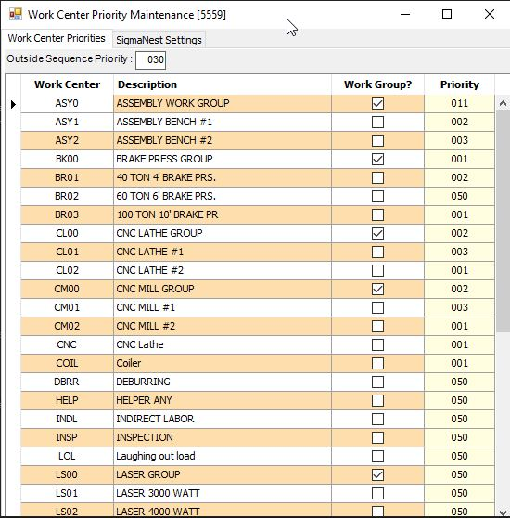The Work Center priorities can be maintained in the menu item Shop Floor Control > Administration > Work Center Priority Maintenance [5559], under the Work Center Priorities tab. All Work Centers and Work Groups will load into the grid, and the priorities can be edited in the priority column on the right. The default is 050. The priority for outside sequences can also be set in the Outside Sequence Priority text box.

Under the SigmaNest Settings tab, the options for the SigmaNest estimate update can be maintained. The path to import the SigmaNest files from can be set in the SigmaNest Import File Path text box. The default employee is which employee labor will be applied to when claiming pieces on the job. The scheduling direction is the direction the work order will be rescheduled after being updated.

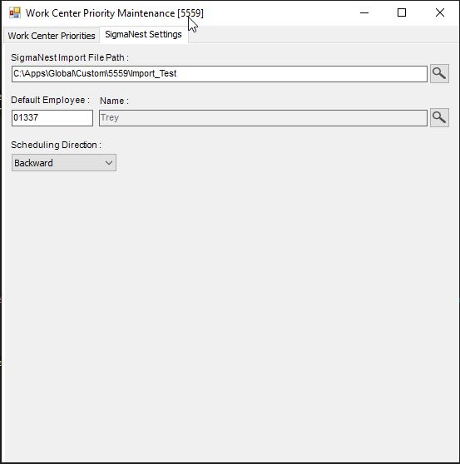

When creating new work orders, either through Shop Floor Control > File > Automated Work Order Generation or Shop Floor Control > File > Work Orders > New. The program will check all of the work centers on the job and assign the highest priority it finds.

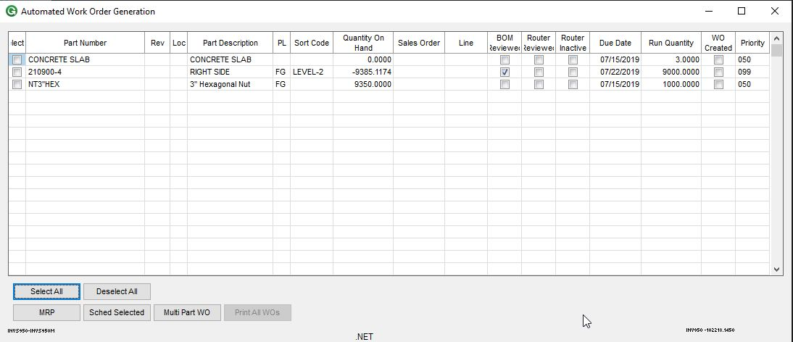

The import will run on online update. After online update processes, the program will check for new files to import. It will then update the estimates, reschedule the jobs, and update the Notes on the Open Work Order dashboard with the task name. It will also read the number of pieces being reported by SigmaNest, and claim that many pieces on the programming step of the job (000100). The time applied will be 0.01 Hours. The programming sequence will then be closed. Attached below is an example of the expected file format. 

The program will maintain a log file named 5559_Log.txt in the Global\Custom\5559 directory. This will update when jobs are found to be updated, or if the program crashes.

A new menu item is also added at Advanced Planning System > View > Open Work Orders w/ Material [5559]. This is the same as the standard open work order dashboard (Advanced Planning System > View > Open Work Orders), except it also has the raw material from the work order as a column. The first material step on the work order is what will be used.

